The University Of Azad Jammu & Kashmir

Student Name: Sakeena Bano
Roll No: 2024-SE-29
Course Title: Software construction & Development
Course Code: SE-3101
Course Instructor: Engr. Dr. Asma Javaid

LAB:02

Foodpanda Online Food Ordering — Activity Diagram with Swimlanes

1. Introduction
Foodpanda is an online platform that allows customers to order food through an app or website. Customers select food, provide delivery details, choose a payment method, and place orders. Restaurants prepare the food, and delivery riders bring it to customers.
The activity diagram illustrates the ordering process and the interaction between customers, the application, restaurants, and riders.

2. Objectives
- Understand online food ordering.
- Identify each participant's responsibilities.
- Show the order of activities.
- Explain payment verification.
- Represent food availability and delivery.

3. Activity Diagram
An activity diagram is a UML diagram that shows the steps and decisions involved in a process. It helps explain how a system works from beginning to end.
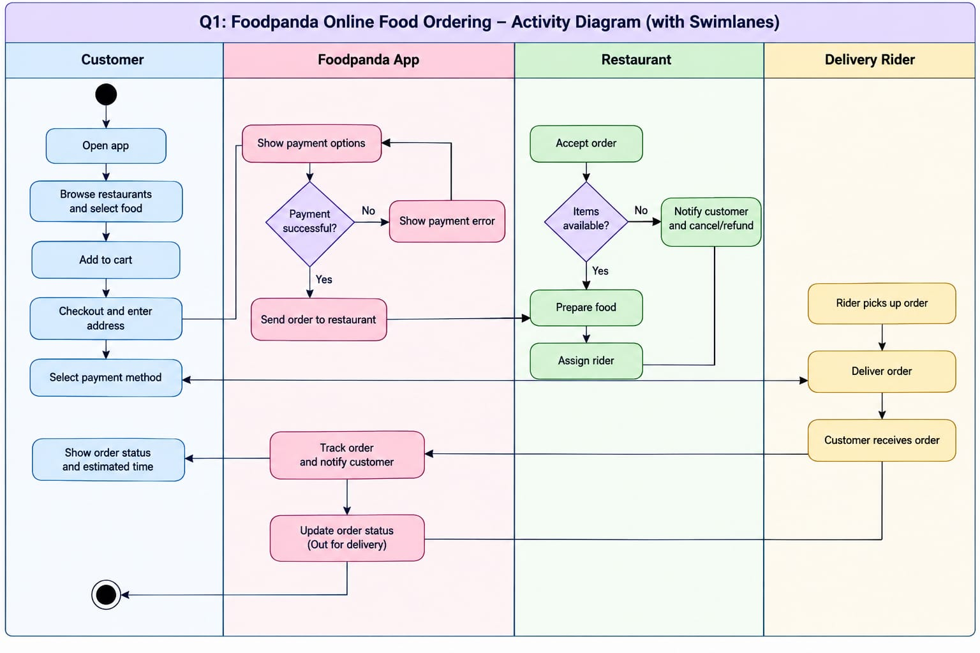

4. Swimlanes
Swimlanes divide activities according to the participant responsible for them.
Customer: Selects food, enters the address, pays, and receives the order.
Foodpanda App: Processes order information, supports payments, and displays order updates.
Restaurant: Receives orders, checks food availability, and prepares meals.
Delivery Rider: Collects prepared food and delivers it to the customer.

5. Symbols Used
- Initial Node: Shows where the process starts.
- Activity: Represents an action or task.
- Decision Node: Shows alternative paths based on a condition.
- Arrows: Indicate the direction of activities.
- Swimlanes: Separate participants' responsibilities.
- Final Node: Indicates the end of the process.

6. Working Procedure
- The customer opens the Foodpanda application.
- Available restaurants and menus are displayed.
- The customer selects food and adds it to the cart.
- The customer enters the delivery address.
- A payment method is selected.
- The application checks the payment result.
- If payment fails, an error appears and the customer can retry.
- If payment succeeds, the order is sent to the restaurant.
- The restaurant checks whether the items are available.
- If items are unavailable, the customer is notified and cancellation or refund may follow.
- If items are available, the restaurant prepares the food.
- The rider collects the order and delivers it.
- The application updates the order status.
- The customer receives the food, and the process ends.

7. Importance of Decision Points
Payment Decision: Determines whether the order can proceed or payment must be retried.
Food Availability Decision: Determines whether the restaurant can prepare the selected items or the order needs cancellation.

8. Roles of Participants
- Customer: Places and receives the order.
- Foodpanda App: Manages order information and updates.
- Restaurant: Checks and prepares the food.
- Delivery Rider: Transports food to the customer.

9. Advantages
- Makes the ordering process easy to understand.
- Clearly defines responsibilities.
- Shows how payment errors are handled.
- Improves communication between participants.
- Helps identify delays and problems.
- Supports software development.

10. Conclusion
The Foodpanda activity diagram explains how an online food order moves from selection to delivery. Its four swimlanes show the responsibilities of the customer, application, restaurant, and rider. Decision points explain how the system handles payment failures and unavailable items.

Toaster — UML State Machine Diagram

1. Introduction
A UML State Machine Diagram represents the different states of a system and the events that cause state changes.
The toaster diagram explains how an automatic toaster heats bread, toasts it, ejects it, and handles problems such as jammed bread.

2. Objectives
- Identify the toaster's states.
- Understand state transitions.
- Explain events that control operation.
- Show how faults are handled.
- Understand the basic UML symbols.
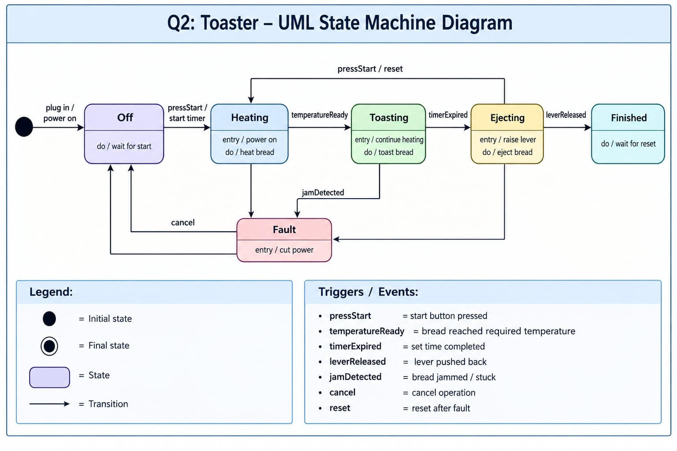

3. Main States
The diagram contains six main states:
- Off: The toaster waits for a start command.
- Heating: The toaster heats the bread.
- Toasting: The bread is toasted for a set time.
- Ejecting: The toaster raises the lever and releases the bread.
- Finished: The toasting cycle is complete.
- Fault: The toaster handles an abnormal condition.

4. State Transitions
Initial → Off: The toaster is connected to power.
Off → Heating: The user presses the start button.
Heating → Toasting: The required temperature is reached.
Toasting → Ejecting: The timer expires.
Ejecting → Finished: The lever is released.
Toasting → Fault: Bread becomes stuck.
Fault → Off: The user cancels or resets the system.
Finished → Heating: The user starts another cycle.

5. Events and Actions
- pressStart: Begins the toasting cycle.
- temperatureReady: Indicates that the required temperature is reached.
- timerExpired: Ends the toasting period.
- leverReleased: Completes the ejection stage.
- jamDetected: Indicates stuck bread.
- cancel: Cancels the operation.
- reset: Restores the system after a fault.
Entry actions describe what happens when a state begins, while do activities describe tasks performed during that state.

6. Working Procedure
- The toaster is connected to electricity.
- It waits for the user to press Start.
- The heating process begins.
- The bread reaches the required temperature.
- The toaster continues toasting until the timer expires.
- The lever rises and the bread is ejected.
- The toaster enters the Finished state.
- If a fault occurs, the toaster enters the Fault state and cuts off heating power.
- After recovery, the toaster returns to its waiting state.

7. Importance
The diagram explains the toaster's normal operation, identifies its states, and shows how it responds to events and faults. It also helps developers design and test control systems.

8. Advantages
- Simplifies the toaster's operation.
- Shows state changes clearly.
- Helps identify faults.
- Supports safety-related design.
- Makes testing easier.

9. Conclusion
The toaster state machine diagram illustrates the complete toasting cycle, from waiting and heating to ejecting the bread. It also explains how the toaster responds to faults and returns to normal operation.

Elevator/Lift — UML State Machine Diagram

1. Introduction
A UML State Machine Diagram shows how a system changes states in response to events.
An elevator uses different states to control floor requests, door operations, movement, and emergency situations.

2. Objectives
- Identify elevator states.
- Explain floor requests and movement.
- Show door operations.
- Describe emergency handling.
- Understand state transitions.
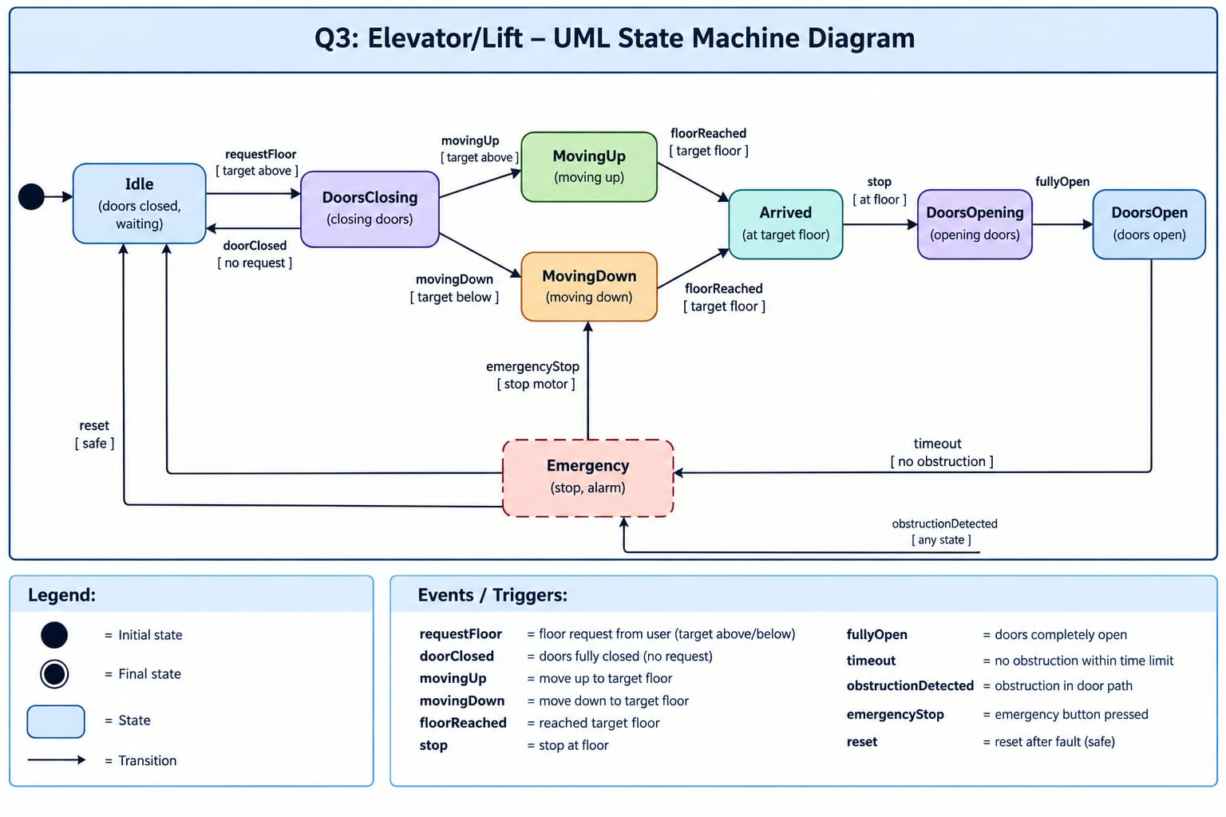

3. Main States
Initial State: Marks the beginning of the system.
Idle: The elevator waits for a floor request.
DoorsClosing: The doors close before movement.
MovingUp: The elevator travels to a higher floor.
MovingDown: The elevator travels to a lower floor.
Arrived: The elevator reaches the requested floor.
DoorsOpening: The doors begin opening.
DoorsOpen: Passengers can enter or exit.
Emergency: Normal operation is interrupted because of a safety-related event.

4. State Transitions
- Initial → Idle: The system starts.
- Idle → DoorsClosing: A floor request is received.
- DoorsClosing → MovingUp: The destination is above.
- DoorsClosing → MovingDown: The destination is below.
- MovingUp → Arrived: The target floor is reached.
- MovingDown → Arrived: The target floor is reached.
- Arrived → DoorsOpening: The elevator stops at the destination.
- DoorsOpening → DoorsOpen: The doors open completely.
- Any State → Emergency: An obstruction is detected, according to the diagram.
- Emergency → Idle: The system is reset after safety is confirmed.

5. Important Events
- requestFloor: A passenger selects a destination.
- doorClosed: The doors are completely closed.
- movingUp: The elevator begins upward movement.
- movingDown: The elevator begins downward movement.
- floorReached: The destination is reached.
- fullyOpen: The doors open completely.
- obstructionDetected: A possible obstruction is detected.
- emergencyStop: An emergency stop is activated.
- reset: The system returns to normal operation when safe.

6. Working Procedure
- The elevator starts in the Idle state.
- A passenger selects a floor.
- The doors close.
- The system determines the direction of travel.
- The elevator moves toward the destination.
- It stops at the selected floor.
- The doors open for passengers.
- If an emergency occurs, normal operation is interrupted.
- The elevator returns to Idle only after the required safety conditions are met.

7. Importance
The diagram helps explain elevator behavior and shows how floor requests, movement, doors, and emergencies are managed. It can also help developers test system logic and identify design problems.

8. Advantages
- Clearly represents elevator operation.
- Explains movement between floors.
- Shows door-control activities.
- Helps identify safety issues.
- Supports software testing and debugging.

9. Conclusion
The Elevator UML State Machine Diagram describes how an elevator receives requests, moves between floors, operates its doors, and responds to emergencies. It provides a clear model of the system's behavior and control logic.

